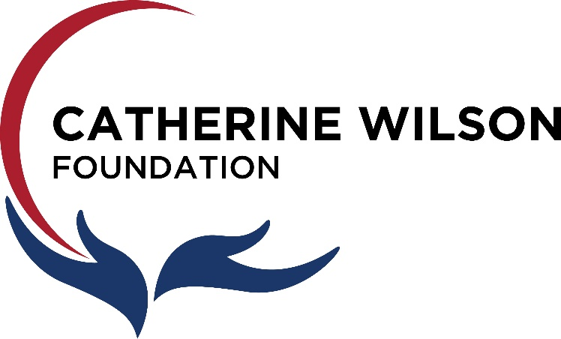 | Annual Report  for 2025

The Catherine Wilson Foundation was established in 1998 (incorporation date of Dec. 11, 1998, by Catherine Wilson and associates. Ms. Wilson was a high school teacher for over 35 years at Sarnia Collegiate Institute & Technical School (S.C.I.T.S.) located in Sarnia, Ontario. Later that school joined with another high school and became Great Lakes Secondary School. She was one of the first financial sponsors in support of the recruitment of doctors to the Sarnia area. She supported vision care in Sarnia because of her own experience with vision issues. Upon her death the balance of her estate was donated to her Foundation with the board of directors acting as the trustees of her estate.

Vision Statement
The Catherine Wilson Foundation will promote a sense of community by being a champion to both individuals and organizations in reaching their full potential.
Mission Statement
The Catherine Wilson Foundation is committed to improving the quality of life of the citizens of Sarnia Lambton by providing scholarships and agency grants.
Values
- Integrity and accountability
- Caring and compassion
- Responsiveness to the community
- Empowerment of others

Fields of Interest

- Education, specifically Great Lakes Secondary School
- Children, Youth and Family
- Health, Social and Community Services
President’s Message

It is so easy for me as Board President to copy, cut and paste last year’s President’s Message for insertion into the Annual Report. Perhaps this year I can digress from the standard and look a little deeper at what the Foundation is about, and what it means to the community.

The Catherine Wilson Foundation is the creation of the late Ms. Wilson, who was a respected teacher at SCITS High School in Sarnia for many years. Ms. Wilson was known to be demanding; you did not attend her class to make trouble! But inside this person was a very caring soul, who cared about her fellow citizens of Sarnia, and in particular the young people she dealt with every day of her lengthy career as a teacher and mentor.

As a result of the caring she had for Sarnia, the community in general and in particular the youth of the community, Ms. Wilson alone created the Foundation with money she had earned, inherited, invested, and nurtured. Money that could have been spent on herself, her needs, and her enjoyment.

She did not spend the money on herself in that way. Instead, she dedicated her wealth to live on after she was gone to care for the people and things that meant so much to her, her school, her church, her youth, and her community.

For the years that I have had the experience of being on the Board of the Foundation, I have had the privilege of assisting in the distribution of grants to various agencies and institutions within the Sarnia Lambton area. Some grants have been small, some large. But each one elicits the same response; thank goodness for people and Foundations like Catherine Wilson and the Catherine Wilson Foundation, for without them, the community would not be the place we are all so blessed to live in.

Caring for our community cannot be left to our various levels of government and to large organizations like the United Way. Each of us, as Ms. Wilson exemplified, are capable of giving in some way. By donating money, if that is within your means, or time, if you have that available, or expertise, if your education and experience can assist those in need.

Large donations of money, time or expertise are important; but giving a little of each by all of us creates the caring community in which we live.

So this year, I want to point out again the wonderful benefit that flows from Ms. Wilson’s caring creation, The Catherine Wilson Foundation; grants for scholarships, libraries and athletics at the high school level, grants for programs to assist in educating children, grants for needy children to get them what they need to have a single great day at school, every day, and grants that support her church, and community youth support groups that are so thankful for the small assist the Foundation can give.

Giving of money, time and expertise may take something out of your life, but it will give so much more back to you in so many ways. Ms. Wilson knew that and I hope you can experience that in some way in your life to find a way to assist the youth in our community as she did.

I want to thank everyone involved in the Foundation this year, including and especially our Executive Director, Ms. Mary Ellen Warren, without whom we would be a ship without a sail; and also to those on the Board who give up their time to make the Foundation’s work possible.

June 1st, 2026

John Ruffilli
Board President.

Members of the Board of Directors 2024-2025
William Chong is retired from being President and owner of Haines Printing in Sarnia.

John Ruffilli is a retired Sarnia Lawyer and Partner at George Murray Shipley Bell LLP.
Dr. Gordon Warren is a practicing Optometrist and owner of Sarnia Optometric and Sarnia Vision Centre.
Scott McKelvie is a retired principal from the Lambton-Kent District School Board. Being a life-long resident of Sarnia, Scott is committed to enhancing the lives of its residents.
Laurie Girard is a retired teacher/coach from the Lambton Kent District School Board having spent 32 years at Great Lakes Secondary School. Born and raised in Sarnia, Laurie has been an active member of the Sarnia Lambton Sports Hall of Fame and volunteer with Sarnia-Bluewaterland Rotary Club through Art in the Park.

Grant Recipients 2025

Great Lakes Secondary School Scholarships, Athletics, Library, English $63,000
Inn of the Good Shepherd Back to School Kits $ 8,000
Sarnia Lambton Rebound Programs for Youth $15,000
Community Concerns for the Medically Fragile $ 5,000
C.N.I B. Sarnia Lambton $ 5,000
St. Andrew’s Church $17,500
Community Living $ 5,000
TOTAL $118,500

Financial Statements 2025
See attached statements as prepared by BDO

